2025 CEOI Collaboration and Creative Ideas Lab
On behalf of the UK Space Agency, the Centre for Earth Observation Instrumentation (CEOI) invites applications from early career researchers to participate in a Collaboration and Creative Ideas Lab. This call, released on 8 July, 2025, is open to early career researchers working in academia, industry or other research institutions based in the UK.
This is an exciting opportunity to experience the process of building collaborative relationships, generating new ideas, and developing technical and business case pitches. The Lab will take the form of a series of professionally facilitated in person and online workshop sessions. Project teams will receive guidance throughout the process from experienced mentors.
The Lab workshop sessions will run in October 2025, with a participant briefing on 26 September.
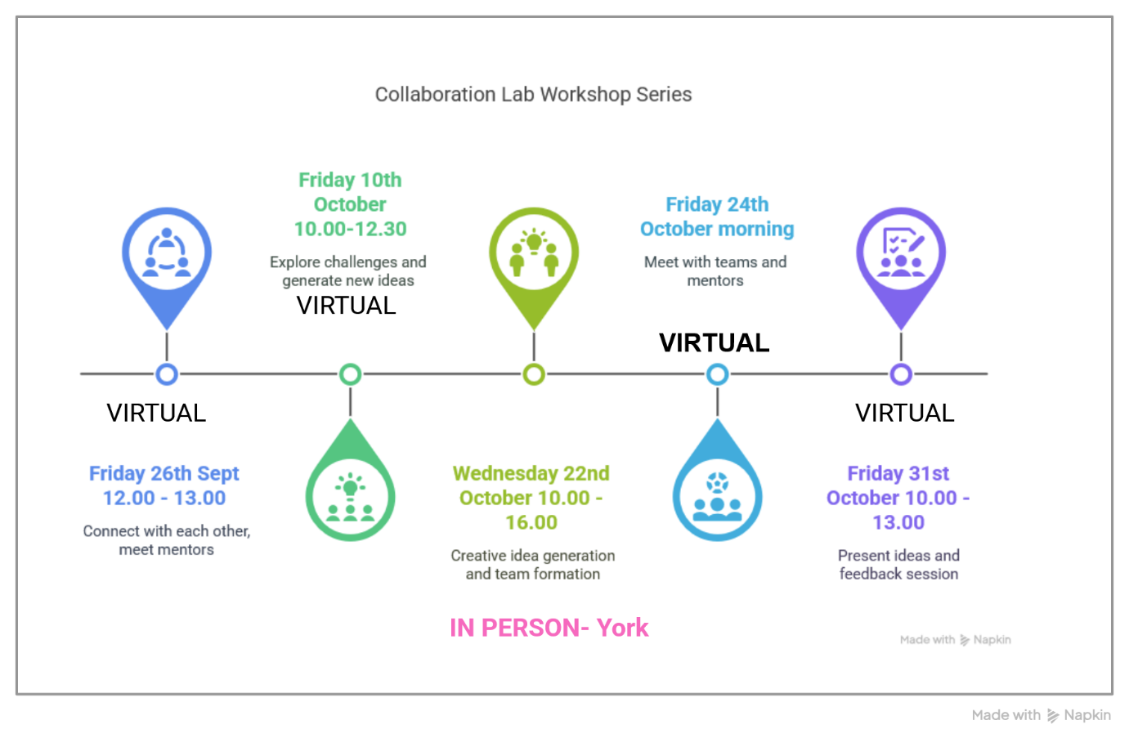

By applying you will be committing to participate in the briefing and all the Lab workshop sessions. It is anticipated that the review of participant applications will be completed by mid-August 2025, with applicants notified shortly afterwards. Please note that attendance of the Lab does not guarantee future project funding.
Detailed instructions for applications including selection criteria are available on the CEOI website (www.ceoi.ac.uk). Please make sure you have read and understood the call’s terms and conditions before submitting an application. Any pre-application queries should be raised with CEOI before submission using the email below.
Applicants should complete the proforma below and submit it by email, with a cover letter (and letter of support from PhD supervisor if you are a PhD student), to ceoiadmin@le.ac.uk before 12.00 BST on Friday 8th August, 2025.
The CEOI has the objective to realise an excellent, internationally competitive national Earth observation instrument and technology research and development programme. This Lab will contribute to this aim by providing training through experience to early career researchers and professionals, who may go on to lead exciting EO technology and application developments in the future.
The CEOI supports the UK Space Agency’s Equality, Diversity and Inclusion objectives.

2025 CEOI Collaboration and Creative Ideas Lab Application Proforma
Personal Information
First Name
Last Name
Title
Work Address
Work Phone Number (mobile or best for contact)
Work email address
LinkedIn page (optional)
Highest academic qualification and date awarded
(include title and institute)

Please note the dates of any career breaks that should be considered in assessing early career status
Current Employment
Starting Date | Position and Employer
1.
2.*
* If your current position started less than 12 months ago, please provide information about your previous position in row 2.
Referee
First Name and Last Name (Title)
Function and Employer
Contact Details (inc official email)

Your expertise, interests and motivation
Please give brief details of your background, and particularly what expertise you will bring to the workshop.
Please summarise your relevant area(s) of research/technical interest, explaining why you think there may be potential for new collaborations to make a difference at this Lab.
Please explain why you would like to participate in the Collaboration and Creative Ideas Lab, and please describe how participation will benefit you regarding career development.
We would like to make the workshops as accessible as possible. It would be helpful to know, for example, if you use a screen reader, or have other accessibility requirements that we can try to accommodate in our planning. Please outline any accessibility requirements or suggestions that would make attending easier for you.
If you require financial support for travel (and, for those travelling farther distances, accommodation), please explain your needs and cost estimate here.
To complete your application, you must tick the boxes to acknowledge these statements.
I am an early career researcher/professional, resident in the UK, and the information I have provided is accurate.
If my application is successful, I agree to fully participate in the briefing and workshop sessions.
I acknowledge that participation in the workshops does not guarantee that I will receive future project funding.
I understand that CEOI team may conduct due diligence on applications in line with the University of Leicester’s Trusted Research guidelines.
I am happy for CEOI to contact me about future opportunities arising directly from the creative ideas lab.
I understand that I may be contacted by UKSA or its agent for the purpose of Monitoring and Evaluation of the CEOI programme for a period of 5 years, and that my contact details will therefore be shared with, and stored by, the relevant entities for this purpose.
If I am a PhD student, I confirm that I will have completed my first year of study by October, 2025 and have included a brief letter of support from my supervisor.
Signature and Date

